Equilibrium: ICE Tables and the Meaning of K
AP Chemistry Notes

1. What K Means
At equilibrium the forward and reverse reactions occur at the same rate, so the concentrations stop changing. The equilibrium constant, K, compares the amounts of products and reactants at that point.
For a reaction aA + bB ⇌ cC + dD:
K = $\frac{[C]^{c} [D]^{d}}{[A]^{a} [B]^{b}}$
- Products go on top, reactants on the bottom, and each concentration is raised to the power of its coefficient.
- K_{c} uses concentrations (mol/L). K_{p} uses partial pressures of gases. They are written the same way.
- Pure solids and pure liquids are left out of K, because their concentrations do not change. Water as the solvent is also left out.
- K depends only on the reaction and the temperature. Changing concentrations or pressure does not change K. Changing temperature does.

What the size of K tells you
Size of K | Meaning at equilibrium
K ≫ 1 (for example 10⁵ or larger) | Mostly products. The reaction goes nearly to completion.
K ≈ 1 | Significant amounts of both reactants and products.
K ≪ 1 (for example 10⁻⁵ or smaller) | Mostly reactants. Very little product forms.

K tells you how far the reaction goes, not how fast. A reaction with a huge K can still be very slow.

Writing K expressions
Example: Write K_{c} for N₂(g) + 3H₂(g) ⇌ 2NH₃(g)
Step 1: Products on top: [NH₃], raised to its coefficient 2.
Step 2: Reactants on the bottom: [N₂] to the 1 and [H₂] to the 3.
Answer: K_{c} = $\frac{[NH₃]²}{[N₂][H₂]³}$

Example: Write K_{c} for CaCO₃(s) ⇌ CaO(s) + CO₂(g)
Step 1: CaCO₃ and CaO are solids, so they are left out.
Step 2: Only the gas remains.
Answer: K_{c} = [CO₂]

Example: Write K_{c} for Ag⁺(aq) + Cl⁻(aq) ⇌ AgCl(s)
Step 1: AgCl is a solid, so it is left out of the top.
Step 2: That leaves a 1 on top.
Answer: K_{c} = $\frac{1}{[Ag⁺][Cl⁻]}$

Changing the reaction changes K
If the reaction is… | Then K becomes…
Reversed | $\frac{1}{K}$
Multiplied by a factor n | K^{n}
Two reactions added together | K₁ × K₂

Example: Adjusting K
Given 2SO₂(g) + O₂(g) ⇌ 2SO₃(g) with K = 4.0.
Reversed: 2SO₃ ⇌ 2SO₂ + O₂ has K = $\frac{1}{4.0}$ = 0.25.
Halved (n = ½): SO₂ + ½O₂ ⇌ SO₃ has K = 4.0^{½} = 2.0.
Doubled (n = 2): 4SO₂ + 2O₂ ⇌ 4SO₃ has K = 4.0² = 16.

Reaction quotient Q: which way will it shift?
Q is written exactly like K but uses the concentrations at any moment, not just at equilibrium. Compare Q to K:
Comparison | What happens
Q < K | Too many reactants. The reaction shifts right (toward products).
Q = K | At equilibrium. No shift.
Q > K | Too many products. The reaction shifts left (toward reactants).

2. ICE Tables
An ICE table organizes an equilibrium problem. I = Initial concentration, C = Change, E = Equilibrium concentration.

The method
- Write the balanced equation and the K expression.
- Set up the table with one column per species (leave out solids and liquids). Fill in the I row with the starting concentrations. If a species is not present at the start, its initial value is 0.
- Fill in the C row using x and the coefficients. Reactants that are used up get −(coefficient)x. Products that form get +(coefficient)x. If you are not sure of the direction, compare Q to K.
- Add each I and C to get the E row.
- Substitute the E row into the K expression and solve for x.
- Use x to find the equilibrium concentrations, then check your answer by putting them back into K.
Tip: the C row always follows the coefficients. In 2A ⇌ B, if A changes by −2x then B changes by +x.

Which type of problem is it?
What you are given | What to do
Initial concentrations and one equilibrium concentration | Use that value to find x, then finish the table and calculate K (Example 1).
Initial concentrations and K | Solve for x. Take the square root of both sides when both sides are perfect squares (Examples 2 and 3).
K is very small (K < about 10⁻³) with a large starting concentration | Assume x is negligible next to the initial value (Example 4).
Concentrations at a moment in time and K | Calculate Q, find the direction, then use an ICE table (Example 5).

Worked examples
Example 1: Finding K from one equilibrium concentration
H₂(g) + I₂(g) ⇌ 2HI(g). A flask starts with 1.00 M H₂ and 1.00 M I₂ and no HI. At equilibrium [HI] = 1.56 M. Find K_{c}.
 | [H₂] | [I₂] | [HI]
I | 1.00 | 1.00 | 0
C | −x | −x | +2x
E | 1.00 − x | 1.00 − x | 2x

- At equilibrium [HI] = 2x = 1.56 M, so x = 0.78 M.
- [H₂] = [I₂] = 1.00 − 0.78 = 0.22 M.
- K_{c} = $\frac{[HI]²}{[H₂][I₂]}$ = $\frac{(1.56)²}{(0.22)(0.22)}$ = $\frac{2.43}{0.0484}$ = 50.
K ≈ 50 is greater than 1, so products are favored.
Example 2: Finding equilibrium concentrations (perfect square)
Same reaction, K_{c} = 50. A flask starts with 0.500 M H₂ and 0.500 M I₂ and no HI. Find the equilibrium concentrations.
 | [H₂] | [I₂] | [HI]
I | 0.500 | 0.500 | 0
C | −x | −x | +2x
E | 0.500 − x | 0.500 − x | 2x

- K_{c} = $\frac{(2x)²}{(0.500 − x)²}$ = 50.
- Both sides are perfect squares. Take the square root: $\frac{2x}{0.500 − x}$ = 7.07.
- Solve: 2x = 3.54 − 7.07x, so 9.07x = 3.54 and x = 0.390.
- [H₂] = [I₂] = 0.500 − 0.390 = 0.110 M. [HI] = 2(0.390) = 0.780 M.
- Check: $\frac{(0.780)²}{(0.110)²}$ = 50. ✓
Example 3: Perfect square with a different reaction
CO(g) + H₂O(g) ⇌ CO₂(g) + H₂(g). K_{c} = 4.0. Starting with 0.60 M CO and 0.60 M H₂O and no products, find the equilibrium concentrations.
 | [CO] | [H₂O] | [CO₂] | [H₂]
I | 0.60 | 0.60 | 0 | 0
C | −x | −x | +x | +x
E | 0.60 − x | 0.60 − x | x | x

- K_{c} = $\frac{[CO₂][H₂]}{[CO][H₂O]}$ = $\frac{x²}{(0.60 − x)²}$ = 4.0.
- Both sides are perfect squares. Take the square root: $\frac{x}{0.60 − x}$ = 2.0.
- Solve: x = 2.0(0.60 − x) = 1.2 − 2.0x, so 3.0x = 1.2 and x = 0.40.
- [CO] = [H₂O] = 0.60 − 0.40 = 0.20 M. [CO₂] = [H₂] = 0.40 M.
- Check: $\frac{(0.40)²}{(0.20)²}$ = $\frac{0.16}{0.040}$ = 4.0. ✓
Example 4: Small K, use the approximation
PCl₅(g) ⇌ PCl₃(g) + Cl₂(g). K_{c} = 1.0 × 10⁻⁵. Starting with 0.50 M PCl₅ and no products, find the equilibrium concentrations.
 | [PCl₅] | [PCl₃] | [Cl₂]
I | 0.50 | 0 | 0
C | −x | +x | +x
E | 0.50 − x | x | x

- K_{c} = $\frac{x²}{0.50 − x}$ = 1.0 × 10⁻⁵.
- K is very small, so very little PCl₅ reacts. Assume x is tiny compared with 0.50, so 0.50 − x ≈ 0.50.
- = 1.0 × 10⁻⁵, so x² = 5.0 × 10⁻⁶ and x = 2.2 × 10⁻³.$\frac{x²}{0.50}$
- [PCl₃] = [Cl₂] = 2.2 × 10⁻³ M. [PCl₅] ≈ 0.50 M.
Example 5: Using Q to find the direction, then an ICE table
H₂(g) + I₂(g) ⇌ 2HI(g), K_{c} = 50. A mixture has [H₂] = 0.10 M, [I₂] = 0.10 M, and [HI] = 0.80 M. Is it at equilibrium? If not, find the equilibrium concentrations.
- Q = $\frac{[HI]²}{[H₂][I₂]}$ = $\frac{(0.80)²}{(0.10)(0.10)}$ = $\frac{0.64}{0.010}$ = 64.
- Q = 64 is greater than K = 50, so there are too many products. The reaction shifts left.
- Because it shifts left, HI decreases and H₂ and I₂ increase:
 | [H₂] | [I₂] | [HI]
I | 0.10 | 0.10 | 0.80
C | +x | +x | −2x
E | 0.10 + x | 0.10 + x | 0.80 − 2x

- K_{c} = $\frac{(0.80 − 2x)²}{(0.10 + x)²}$ = 50. Take the square root: $\frac{0.80 − 2x}{0.10 + x}$ = 7.07.
- Solve: 0.80 − 2x = 0.707 + 7.07x, so 0.093 = 9.07x and x = 0.010.
- [H₂] = [I₂] = 0.110 M. [HI] = 0.80 − 2(0.010) = 0.78 M.
Notice these match Example 2. The same equilibrium is reached from either direction because K depends only on the reaction and the temperature.

3. Q vs K in Problems: How to Picture It
Q and K are calculated the same way. The only difference is when the concentrations are measured: K uses the concentrations at equilibrium, and Q uses the concentrations right now. Q tells you where the system is, and K tells you where it is headed.

A picture to keep in your head
Think of K as a target line. Wherever Q sits, the reaction moves toward K.
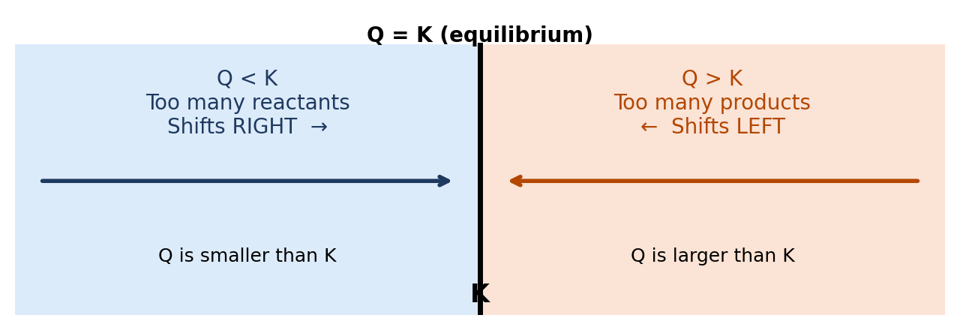
- Q < K: the fraction $\frac{products}{reactants}$ is too small, so the reaction makes more products. It shifts right.
- Q > K: the fraction is too big, so the reaction makes more reactants. It shifts left.
- Q = K: nothing changes. The system is at equilibrium.
Shortcut: the reaction always shifts in the direction that makes Q move toward K. If Q is too small, make the top (products) bigger. If Q is too big, make the bottom (reactants) bigger.

Using the picture in a problem
- Write the K expression, and write Q the same way.
- Plug the given concentrations into Q. (Use the concentrations at that moment, not at equilibrium.)
- Compare Q to K and decide the direction using the picture above.
- Use the direction to set the signs in the C row of an ICE table: shifting right means reactants −, products +. Shifting left is the opposite.
Example A: Which way does it shift?
N₂O₄(g) ⇌ 2NO₂(g), K_{c} = 0.36. A flask contains 0.020 M N₂O₄ and 0.100 M NO₂. Is it at equilibrium? If not, which way does it go?
- Q = $\frac{[NO₂]²}{[N₂O₄]}$ = $\frac{(0.100)²}{0.020}$ = $\frac{0.010}{0.020}$ = 0.50.
- Compare: Q = 0.50 is greater than K = 0.36.
- Too many products, so the reaction shifts left: [NO₂] decreases and [N₂O₄] increases until Q falls to 0.36.
 | [N₂O₄] | [NO₂]
I | 0.020 | 0.100
C | +x | −2x
E | 0.020 + x | 0.100 − 2x

Because the reaction shifts left, the N₂O₄ column goes up (+x) and the NO₂ column goes down (−2x).
Example B: Disturbing an equilibrium (Le Chatelier and Q)
H₂(g) + I₂(g) ⇌ 2HI(g), K_{c} = 50. At equilibrium [H₂] = 0.110 M, [I₂] = 0.110 M, [HI] = 0.780 M. Then 0.500 M HI is added, making [HI] = 1.280 M. Which way does the reaction shift, and what are the new equilibrium concentrations?
- Right after the addition, calculate Q using the new concentrations: Q = $\frac{(1.280)²}{(0.110)(0.110)}$ = $\frac{1.638}{0.0121}$ = 135.
- Q = 135 is greater than K = 50, so the reaction shifts left. This matches Le Chatelier's principle: adding a product shifts the reaction toward reactants.
- Set up the ICE table with the new concentrations as the initial values:
 | [H₂] | [I₂] | [HI]
I | 0.110 | 0.110 | 1.280
C | +x | +x | −2x
E | 0.110 + x | 0.110 + x | 1.280 − 2x

- K_{c} = $\frac{(1.280 − 2x)²}{(0.110 + x)²}$ = 50. Both sides are perfect squares, so take the square root: $\frac{1.280 − 2x}{0.110 + x}$ = 7.07.
- Solve: 1.280 − 2x = 0.778 + 7.07x, so 0.502 = 9.07x and x = 0.055.
- [H₂] = [I₂] = 0.110 + 0.055 = 0.165 M. [HI] = 1.280 − 2(0.055) = 1.17 M.
- Check: $\frac{(1.17)²}{(0.165)²}$ = $\frac{1.37}{0.0272}$ = 50. ✓
The graph below follows Q during this shift. Adding HI pushed Q up to 135. As the reaction runs to the left, Q falls back until it equals K again. K itself never changed. Only Q moved.
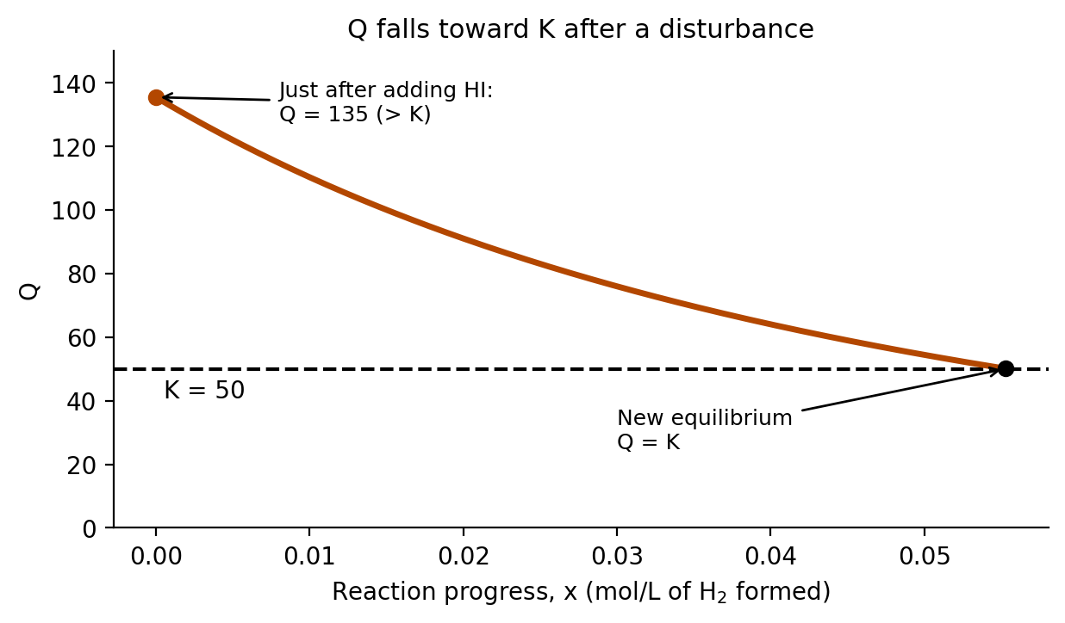
Example C: Is it at equilibrium? (Q = K)
N₂(g) + 3H₂(g) ⇌ 2NH₃(g), K_{c} = 0.50. A mixture has [N₂] = 1.0 M, [H₂] = 2.0 M, and [NH₃] = 2.0 M. Is it at equilibrium?
- Write Q with the coefficients as exponents: Q = $\frac{[NH₃]²}{[N₂][H₂]³}$.
- Substitute: Q = $\frac{(2.0)²}{(1.0)(2.0)³}$ = $\frac{4.0}{8.0}$ = 0.50.
- Q = 0.50 equals K = 0.50, so the mixture is at equilibrium. There is no shift, and the concentrations stay the same.

Quick reference
Q vs K | Reaction shifts | Reactants | Products
Q < K | Right → | decrease | increase
Q = K | No shift | constant | constant
Q > K | ← Left | increase | decrease

4. Common Mistakes
- Forgetting to raise concentrations to the power of their coefficients in K.
- Including solids or liquids in K.
- Using x instead of 2x (or 3x) in the K expression when the coefficient is 2 (or 3). The C row follows the coefficients, and the coefficient stays as a multiplier of x.
- Adding x to reactants when the reaction shifts right. Reactants decrease when products form.

